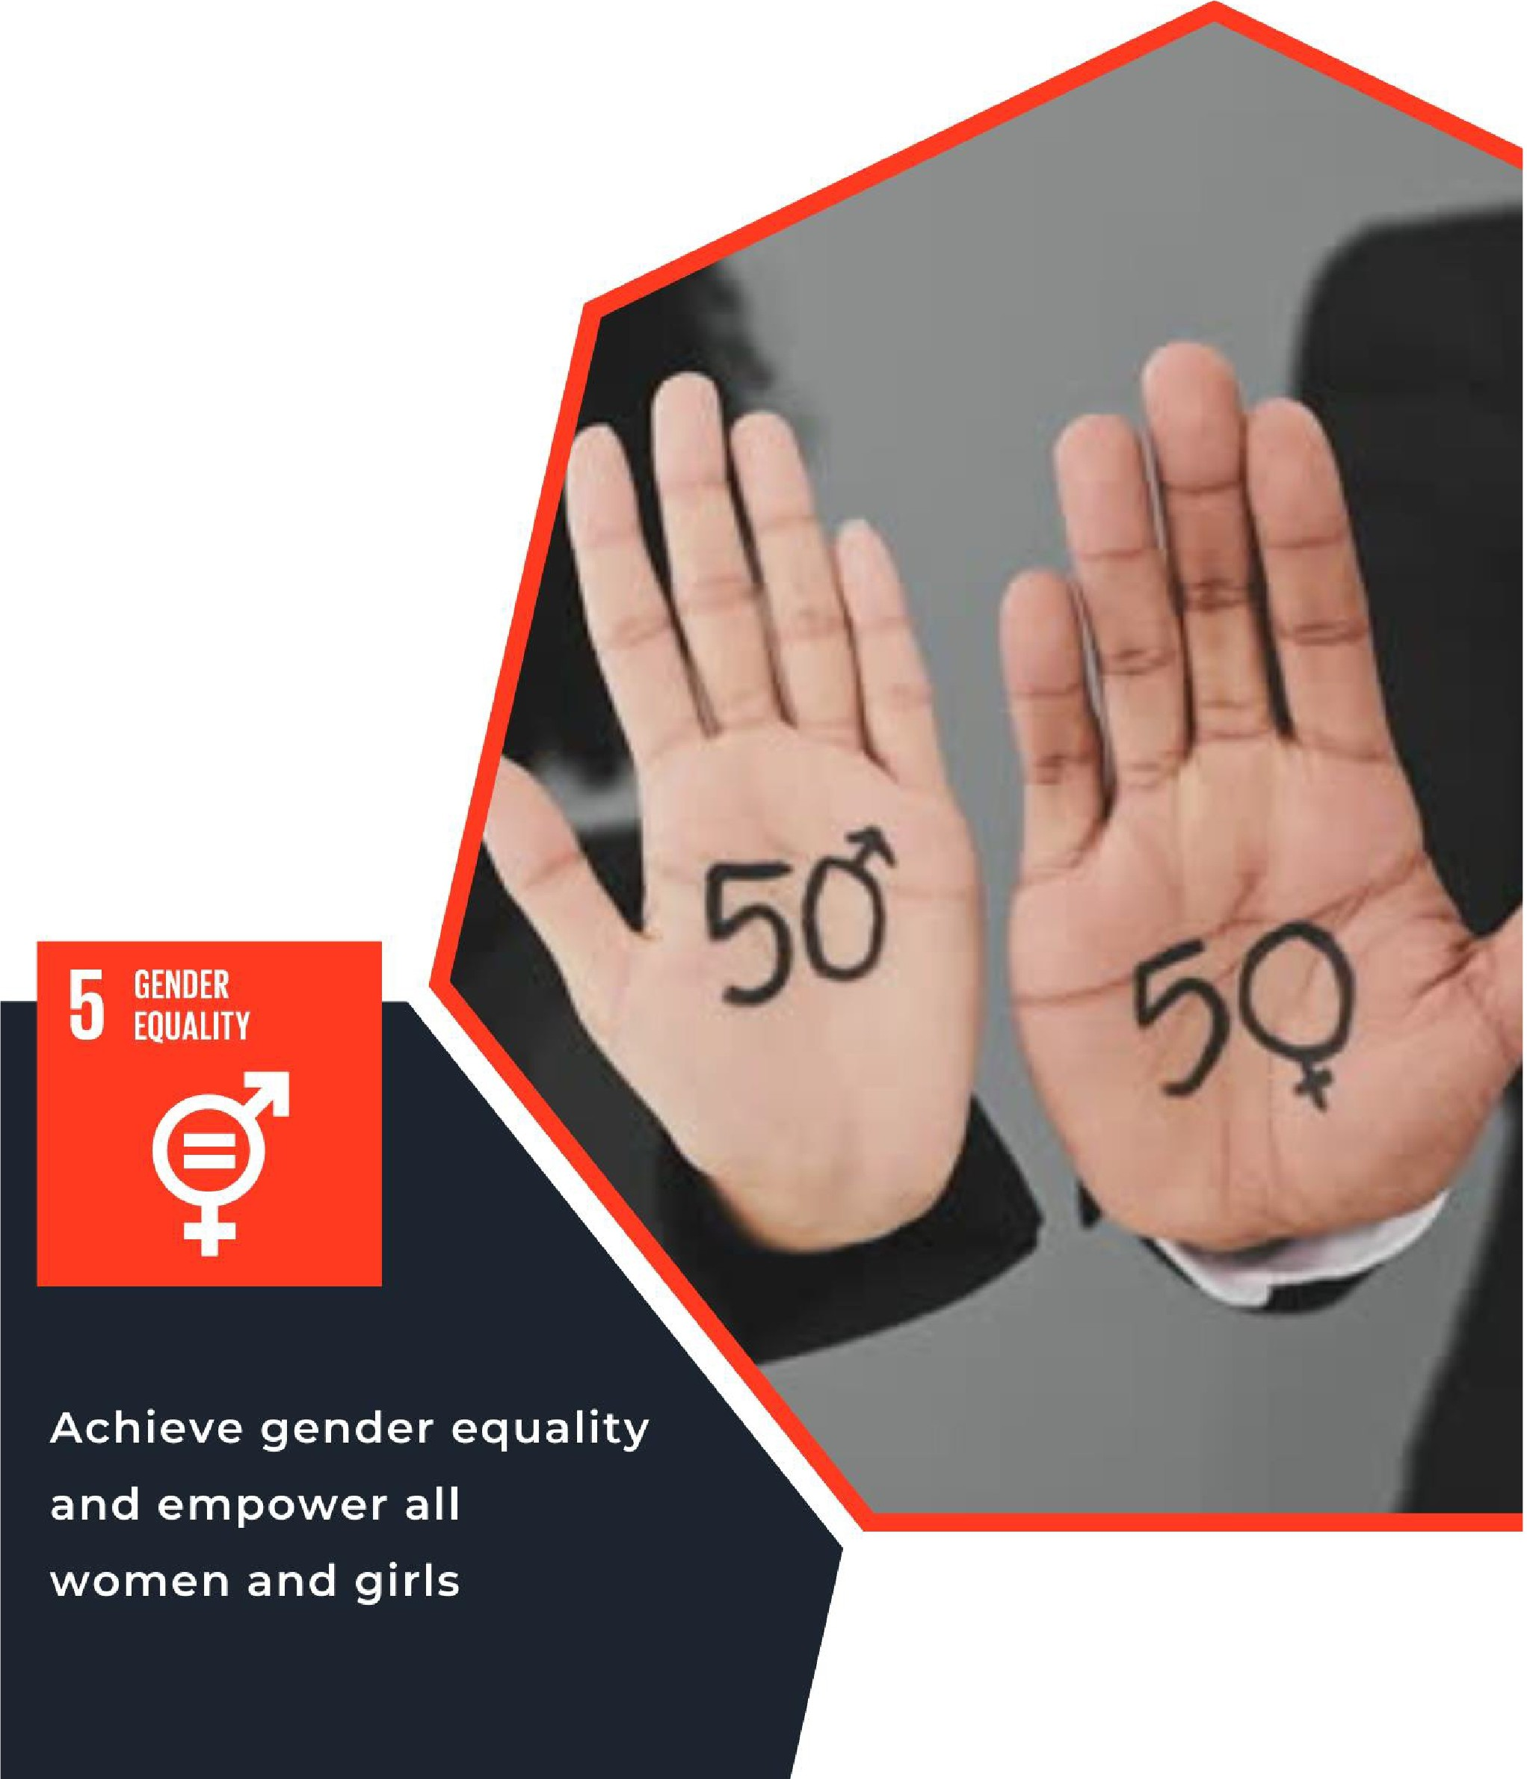LESSON EIGHT

SUSTAINABLE DEVELOPMENT GOAL #5, GENDER EQUALITY

For Educators

IMAGE BY ISTOCK

# Lesson 8: Sustainable Development Goal #5: Gender Equality Student Handout

**Module Driving Questions: Lessons 7, 8, and 9 *(Choose one or both these module questions)***

* Do you believe local and global efforts to decrease hunger, achieve gender equality, and provide reliable access to clean water and sanitation are fundamental human rights? Why or why not?
* How have environmental factors affected local and global efforts to decrease hunger, achieve gender quality, and provide reliable access to clean water and sanitation?

**Lesson Driving Questions**

* How is gender inequality impacting communities across the world?
* How does the empowerment of women and girls impact other global issues, such as climate change, education, or access to clean water and sanitation?
* What can be done to achieve gender equality? What opportunities and challenges exist?

**Learning Targets – I Can:**

* Explain how gender equality is a critical goal in supporting the economic, social, and political empowerment of women and girls locally and globally.
* Analyze the sources of gender bias and determine actions to create a more equitable society.
* Evaluate and explain how the empowerment of women and girls will support fundamental human rights for all and create more stable societies around the world.

**Purpose**

In this lesson, you will learn about United Nations Sustainable Development Goal #5: Gender Equality. You will conduct research and watch videos that explain the importance of empowering women and girls, including the role this plays in creating stable societies around the world. You will also analyze gender equality as a fundamental human right and engage in small and large group activities to analyze the economic, social, and political impact of gender inequality on individuals and communities. You will utilize diverse sources and participate in collaborative discussions. These learning activities include analyzing SDG #5 target goals, reflecting on the conclusions of your peers in group discussions, and researching efforts to decrease gender bias in a specific local, national, or global community. Finally, you will work individually and collectively to generate ideas to decrease gender inequality and empower women and girls.

**Lesson Vocabulary**

Gender equality, human rights, women and girls’ empowerment, NGO, bias, inclusive, discrimination,

policy, global health, poverty reduction, climate change, policy, social norms, gender quotas.

**Lesson Steps**

1. **Warm-Up Activity: Reflect** and **respond** to these questions in your notebook: *What does it mean to be equal? Why do you think gender equality is considered a fundamental human right?* Use the Jamboard link or a KWL chart to organize your thoughts. Then, join a small group to **share your thoughts** and **discuss** with others.
2. **Research** SDG #5: Gender Equality. Explore the [UN SDG webpage](https://sdgs.un.org/goals/goal5) to learn about the different indicators, targets, and progress of Goal #5. Prepare to **share your findings** with the class. Try to find a fact about SDG #5 that you think nobody else will!
3. **Learn** about the targets of SDG #5 and **think** about what we can do to reach these targets. **Write down** 5 steps someone could take to promote gender equality in their day-to-day lives.
4. **Watch** [this video](https://www.youtube.com/watch?v=vXlJEcrinwg) about the empowerment of women and girls. Take a few minutes to note down your initial thoughts and any questions that come up for you while watching. Consider why empowering women and girls plays a role in achieving SDG #5. Then, **engage in a class discussion.**
5. **Think-Pair-Share:** *What would the world be like if we were to achieve gender equality? What would be different? What would stay the same?* **Brainstorm** some ideas and **share** them with a partner.
6. **Brainstorm** the different causes of gender inequality. In a small group, **discuss** these causes and **propose solutions** to the rest of the class. Think about if there are any consequences or challenges in executing these solutions.
7. **Explore** organizations that are doing work to promote gender equality. Can you find some in the United States? What about in other countries? Pick one organization you want to focus on and **prepare a 2-minute presentation** to give to the class about your organization.
8. **Case Study**: **Research** and **analyze** how climate change has become a gender equality issue. Examine how environmental factors play a role in impacting gender equality goals by diving deeper into the Solomon Islands (or another location) where climate change is affecting women and girls.
9. As a journalist, **write an editorial** in which you describe the factors that make a country or community more susceptible to inequality between genders, using specific evidence to support your claims. **Compare** the

U.S to another country and **examine** the economic, social, and political impacts of gender bias. In conclusion, **propose** two or more solutions to address gender equality.

|  |
| --- |
| **Teacher Preparation Notes** |
| **Pacing and Strategy:** The following outline provides a guide for teaching this lesson including approximate times (may vary), teaching strategies, suggested information for teacher created slides, and options for additional enrichment activities/summative assessments can be found at the end of the modules. This curriculum model was designed with teaching and learning strategies that could be adapted for in-person or virtual learning.  **Lesson Timing:** 120 (approximate) |

**Standards**

|  |  |
| --- | --- |
| **Content** | **Standard** |
| [WA Social Studies](https://ospi.k12.wa.us/student-success/resources-subject-area/social-studies/social-studies-learning-standards-graduation-requirements) | **SSS1.6-8.1:** Analyze positions and evidence supporting an issue or an event.  **SSS3.6-8.1:** Engage in discussion, analyzing multiple viewpoints on public issues.  **C4.11-12.2:** Analyze and evaluate ways of influencing local, state, and national governments and international organizations to establish or preserve individual rights and/or promote the common good. |
| [Social & Emotional](https://ospi.k12.wa.us/sites/default/files/2023-08/selstandardsbenchmarksindicatorslongform_0.pdf) [Learning Standards](https://ospi.k12.wa.us/sites/default/files/2023-08/selstandardsbenchmarksindicatorslongform_0.pdf) | **Benchmark 3C:** Demonstrate awareness and ability to speak on behalf of personal rights and advocacy.  **Benchmark 4B:** Demonstrates an awareness and respect for similarities and differences among community, cultural, and social groups  **Benchmark 6A:** Demonstrates a sense of school and community responsibility. |
| [C3 Framework](https://www.socialstudies.org/standards/c3) | **D4.1.9-12:** Construct arguments using precise and knowledgeable claims, with evidence from multiple sources, while acknowledging counterclaims and evidentiary weaknesses.  **D2. Civ.14.9-12:** Analyze historical, contemporary, and emerging means of changing societies, promoting the common good, and protecting rights.  **D4.6.9-12:** Use disciplinary and interdisciplinary lenses to understand the characteristics and causes of local, regional, and global problems; instances of such problems in multiple contexts; and challenges and opportunities faced by those trying to address these problems over time and place. |

**Lesson Resources**

|  |  |  |
| --- | --- | --- |
| **For Students** | **For Educators** | **Materials** |
| * KWL Chart *(if not using Jamboard)* * Graphic Organizers * Research Notes Sheet * Climate Change Link * Links to UN website and Ted Talk | * KWL Chart *(if not using Jamboard)* * Lesson 8 Slide Outline * Graphic Organizers * Research Notes Sheet * Climate Change Link * Links for prep. and Ted Talk | * KWL Chart *(if not using Jamboard)* * Graphic Organizers * Research Notes Sheet * Climate Change Link |

**Lesson Overview**

In this lesson, students learn about United Nations Sustainable Development Goal #5: Gender Equality. They will conduct research and watch videos that explain the importance of empowering women and girls, including the role this plays in creating stable societies around the world. This specific lesson has students explore gender equality as a fundamental human right *(one of the themes of this module)* and engages them in small and large group activities to analyze the economic, social, and political impact of gender bias on individuals and in communities. Students will consult secondary and primary sources and participate in collaborative discussions. These learning activities include reflcting on the conclusions of their peers in groups discussions and researching efforts to decrease gender bias in specific local, national, or global communities. Finally, students will evaluate what is being done to address gender inequality and how they can act individually and collectively to empower women and girls.

**Teacher Preparation**

**For Step 1**: Research different definitions of equality and find the similarities and differences between them. This will help prepare you for the various kinds of responses your students will have. Prepare to lead a discussion that highlights those similarities and differences to emphasize the role that perception can play in equality.

Then, explore [this website](https://www.un.org/en/global-issues/human-rights#%3A~%3Atext%3DHuman%20rights%20are%20rights%20inherent%2Cand%20education%2C%20and%20many%20more) to understand the different kinds of fundamental human rights and consider how gender equality falls under this term.

**For Step 2:** Examine the United Nations website on the 17 Sustainable Development Goals. This will give you an overview of the different goals if you are not familiar with them. Then, explore the [website for UN SDG](https://sdgs.un.org/goals/goal5) [#5](https://sdgs.un.org/goals/goal5) to become familiar with this global goal and to understand the specific targets that iterate the causes and consequences of gender inequality.

Prepare to lead a class discussion on the students’ findings.

**For Step 3:** Research the [specific targets of SDG #5](https://sdgs.un.org/goals/goal5#targets_and_indicators) to explain them to your students. Prepare for your class to engage in a brainstorming discussion about the different things people/groups could do to achieve these targets. In addition, learn about factors that could affect gender equality in various contexts in preparation for a class discussion. Here are a few websites that can provide background information: [OHCHR,](https://www.ohchr.org/en/women)

Your students will be writing down 5 steps someone could take in their daily lives to help achieve gender equality, so come prepared with some ideas or examples.

**For Step 4:** Watch [the TedTalk video](https://www.youtube.com/watch?v=vXlJEcrinwg), which you will be showing your class. Conduct some additional research about the impact that empowering women and girls has on the greater world to prepare for your class's discussion. Consider exploring the [World Bank website](https://www.worldbank.org/en/topic/gender/brief/womens-girls-empowerment) on female empowerment, [this article](https://peacecorps.gov/educators/resources/global-issues-gender-equality-and-womens-empowerment/) from the Peace Corps, and [this article](https://www.imf.org/external/pubs/ft/fandd/2012/03/revenga.htm) from the International Monetary Fund. It is important that you have a grasp on the affect that female empowerment has on other aspects of modern society, so research until you feel prepared.

**For Step 5:** Consider the reflective questions in Step 5 and come up with your own answers to prepare. As the students share their answers, come up with some counterarguments to get them to think critically about the depth of inequality among genders.

**For Step 6:** Prepare to lead a class discussion on solutions of gender equality and come up with some of your own. Make sure that, with each proposed solution, you are prepared to ask about what consequences there may be or what challenges may come up in trying to execute a particular solution. This step will help your students consider gender equality and the complexity of possible solutions.

**For Step 7:** Look through [this list](https://www.humanrightscareers.com/magazine/organizations-gender-equality/) of different organizations working to promote gender equality. Review what kinds of things you would like included in your students’ 2-minutes presentations so you can communicate that during the lesson. During the lesson, try to ensure that each of your students picks a different organization, so you can discuss as many as possible.

**For Step 8:** This activity allows students to analyze a factor, such as climate change, that is impacting women in a global setting. You will ask students to consider how specific factors *(environmental, political, cultural, social, economic, COVID-19, etc.)* may impact efforts to address gender equality. Utilize this [link](https://www.unfpa.org/stories/climate-crisis-gender-equality-crisis) as example to demonstrate how a factor such as climate change could impact the lives of women and girls. This brief article discusses how climate change is affecting gender equality efforts in the Solomon Islands. Show this link on your screen and discuss how climate is impacting women/girls in this small Pacific Island Nation.

Next, have students complete a WebQuest that asks them to explore a global context in which gender equality is impacted by environmental *(or climate change)* or other factors *(education, water & sanitation access, economic equality, etc.).* This inquiry will deepen student understanding of the various barriers (or factors) that may affect achieving gender equality goals. You can provide possible examples to students and here are some sources to examine as background:

## Check out these websites: climate and environmental factors:

* [How are Gender Inequality and Climate Change Interconnected](https://www.unwomen.org/en/news-stories/explainer/2022/02/explainer-how-gender-inequality-and-climate-change-are-interconnected)
* [Women, Gender Equality, and Climate Change](https://www.un.org/womenwatch/feature/climate_change/downloads/Women_and_Climate_Change_Factsheet.pdf)
* [Video Clip: Four Reasons Why Women are More Impacted by Climate Change](https://www.cnn.com/videos/world/2023/11/24/climate-change-women-impact-explained-as-equals-lon-orig.cnn)
* [Campaign for Female Education (CAMFED): Climate Action](https://camfed.org/us/climate-action/)
* [Geneva Environment Network: Gender & the Environment](https://www.genevaenvironmentnetwork.org/resources/updates/gender-and-the-environment/)
* [Promoting Gender Equality and the Environment](https://www.unep.org/regions/asia-and-pacific/regional-initiatives/promoting-gender-equality-and-environment)
* [Climate Justice and Gender Equality](https://www.undp.org/blog/gender-equality-cornerstone-environmental-and-climate-justice)

## Check out these websites: other global factors:

* [Peace Corps and Gender Equality](https://www.peacecorps.gov/educators/resources/global-issues-gender-equality-and-womens-empowerment/)
* [Global Lens on Gender Equality at Universities](https://www.un.org/en/academic-impact/global-lens-gender-equality-universities-reviewing-their-performance)
* [Gender Quality and the Pandemic](https://www.unwomen.org/en/digital-library/publications/2022/06/government-responses-to-covid-19-lessons-on-gender-equality-for-a-world-in-turmoil)
* [Gender Equality in Health](https://www.paho.org/en/topics/gender-equality-health)
* [European Institute of Gender Equality (Cultural/Social Factors)](https://eige.europa.eu/gender-mainstreaming/policy-areas/culture?language_content_entity=en)
* [International Monetary Fund (IMF): Gender Equality & Economic Growth](https://www.imf.org/en/News/Articles/2022/09/27/sp092722-ggopinath-kgef-gender-korea)
* [UN Women: Facts and Figures: Economic Empowerment](https://www.unwomen.org/en/what-we-do/economic-empowerment/facts-and-figures)

**For Step 9:** Create a rubric for the assigned editorial. Consider the students’ understanding of contributors to gender inequality, the different impacts of gender bias, and their grasp on the plausibility of inequality solutions. Determine your expectations for the editorial and how you will communicate those to students.

**Lesson Plan in Detail**

## Step One: Introduction to Gender Equality: 15 minutes

**Purpose**: Students are introduced to what it means to be equal and why gender equality is considered a fundamental human right. This will provide them with a useful foundation as they prepare to discuss gender equality in more complex ways as the lesson moves forward.

They will be reflecting and brainstorming what they know (or think they know) and what they would like to learn using the Jamboard link. If you prefer, you can use the KWL Chart provided as a handout.

**Slide 1:** Different definitions of equality. KWL Chart/Jamboard instructions. You can share an example of your knowledge of how gender inequality is impacting individuals and communities locally and/or globally. Discuss student ideas.

## Step Two: Learning about the UN SDGs and Goal #5: Gender Equality: 10 minutes

**Purpose**: Explain to students they will be exploring the UN Sustainable Development Goals. Depending on their knowledge of the SDGs, introduce their purpose and show them a graphic of the 17 goals. Then, explain that this lesson focuses on gender equality. Students will have individual time to research this global goal, strengthening their research abilities as they try to find a fact that nobody else will.

**Slide 2:** UN SDG overview slide of the 17 goals. Overview of Goal #5: Gender Equality.

## Step Three: Exploration of SDG #5 Targets: 10 minutes

**Purpose:** Students will learn about the specific targets of SDG#5 so they can begin to understand the different kinds of factors that affect gender equality. They will have the opportunity to brainstorm as a class, different ways to try to achieve these targets and have time on their own to write down the ones they resonate with the most.

**Slide 3:** List of the targets of SDG #5.

## Step Four: Empowerment of Women and Girls: 20 minutes

**Purpose:** Students will watch a Ted Talk about how empowering women and girls affects the greater world, specifically in reference to climate action. This will help them to understand why gender equality is one of the

17 global goals and provide them with the opportunity to ask questions about the complexities and interconnectedness of the UN SDGs and the impact of female empowerment around the world.

**Slide 4:** Embedded video link. Instructions for reflection.

## Step Five: Think-Pair-Share: Gender Equality: 10 minutes

**Purpose:** Students will work on their own to think about what changes we would see in the world if gender equality were to be achieved. This activity is meant to reflect upon what students have learned so far and will help to uncover any areas that may need more attention.

**Slide 5:** Include the questions for reflection. Share some of your own examples from your reflection on the same questions.

## Step Six: Causes of and Solutions for Gender Inequality: 15 minutes

**Purpose:** Students will work in groups to discuss the different causes of gender equality and to come up with potential solutions. This will give them the chance to work with their peers to garner a holistic perspective on gender inequality.

While brainstorming solutions, students will be asked to consider the difficulties or consequences that may come about with their solutions, challenging narrowminded thinking and forcing students to reconcile with the complexity of achieving gender equality.

**Slide 6:** Include an example of one solution to gender inequality and describe the challenges in executing that solution, as well as any potential consequences. This will help students have an example of the work you expect them to do.

## Step Seven: Organizations that Promote Gender Equality: 30 minutes

**Purpose:** This step will bring to life the discussions that your class has been having up to this point by illustrating real organizations and the work that they are doing to achieve Goal #5. By focusing on one organization each, students will be able to engage more deeply with this topic.

In preparing a short presentation, students will become very familiar with the work of one organization, but by listening to their peers, your class will end up with a lot of great examples of positive work towards achieving gender equality.

**Slide 7:** Share an example of an organization that works in gender equality. Use this slide as an example of

what you would like included in your students’ presentations.

## Step Eight: Gender Equality and Global Connections: 30 minutes

**Purpose:** This step will allow students to make connections between gender equality and the world. Students will learn about different contexts and there are a couple of different options for teachers. For example, you could focus on the theme of the environment, including climate change, and how gender equality is linked to this issue. If you want to broaden the WebQuest activity to include other topics impacting gender equality *(education, health, economics, etc.)* from a global perspective, brainstorm possible ideas and contexts with students *(for background and resource links under teacher preparation).* After completing their WebQuest in small groups, students can share what they learned in large group discussion, or you could have students post their conclusions around the classroom for a gallery walk.

**Slide 8:** Share the [Solomon Islands](https://www.unfpa.org/stories/climate-crisis-gender-equality-crisis) as an example *(see teacher preparation section)* and instructions for the WebQuest. Identify this inquiry's purpose and the relevance of connecting the local to the global on gender equality.

## Step Nine: Writing an Editorial: 45 minutes

**Purpose:** This activity lets students work independently to synthesize the work they have done and to apply what they learned throughout this lesson. By framing this activity as an editorial written by a journalist, students will be required to use specific evidence to support their claims, pushing for further research as they delve into the intricacies of gender equality both in the United States and in other countries across the world.

This activity will also guide students to examine the economic, social, and political impacts of gender bias. If students require a review of specific example, have students work in small groups to brainstorm ideas for their editorials. If you utilized the climate change example in step 8, students could go deeper on that subject or explore one of the factors affecting equality goals for women and girls. Students could also highlight the history or gender inequality in the U.S. or another context and discuss how they would take action to address the issue.

**Slide 9:** List the requirements for this assignment *(word count, formatting, content, etc.).*

## Explore Further: Connecting the Local and the Global

The UN Sustainable Development Goals provide a great teaching opportunity to connect the “local” to the “global.” In this context, students can explore local organizations that are working on gender equality in Washington State/the Pacific Northwest. In addition, educators can teach about the important role of NGOs or non-profit organizations in addressing local and global issues.

Students will have an opportunity to examine different organizations in **Step Seven**, so ask them to share the larger list with your class.

To start, here are some local organizations that work to promote gender equality:

* [Washington Women’s Foundation](https://wawomensfdn.org/)
* [Gender Justice League](https://www.genderjusticeleague.org/)
* [Washington State Women’s Commission](https://wswc.wa.gov/)
* [National Organization for Women, Seattle](https://www.nowseattle.org/)
* [Center for Women & Democracy](https://www.womenanddemocracy.org/)
* [Washington Women in Need](https://wwin.org/)

**Note**: If you are using this resource for students outside of Washington State, there are many similar organizations doing work around gender equality across the United States.

**Attribution and License**

# Attribution

This Open Educational Resource, *Cultivating Global Competence through the United Nations Sustainable Development Goals*, was developed by Ryan Hauck, Julianna Patterson, Emma Hansen, Riya Kalra, and Global Classroom, World Affairs Council - Seattle.

*Graphics:*

* Cover image by Julianna Patterson from Canva.
* Sustainable Development Goals images copyright [United Nations](https://sdgs.un.org/)*.* All rights reserved. Used pursuant to fair use.

# License



Except where otherwise noted*,* [*Cultivating Global Competence through the United Nations Sustainable*](https://oercommons.org/courseware/lesson/105481?__hub_id=1)[*Development Goals*](https://oercommons.org/courseware/lesson/105481?__hub_id=1), by [World Affairs Council of Seattle](https://www.world-affairs.org/), is available under a [Creative Commons Attribution-](https://creativecommons.org/licenses/by-nc/4.0/) [NonCommercial License](https://creativecommons.org/licenses/by-nc/4.0/). All logos and trademarks are property of their respective owners. Sections used under fair use doctrine (17 U.S.C. § 107) are marked.

*This resource may contain links to websites operated by third parties. These links are provided for your convenience only and do not constitute or imply any endorsement or monitoring by the World Affairs Council. Please confirm the license status of any third-party resources and understand their terms of use before reusing them.*